

pIWIK PRO SHAREPOINT analytics – SP Online connector – how to uninstall

Contents

1. Introduction 3

1.1. Purpose of this document 3

1.2. Prerequisites 3

2. Install Piwik PRO components in SharePoint 3

2.1. Provision SharePoint components 3

2.2. Configure Piwik PRO connection 4

3. Install PiwikPRO components in Azure 5

3.1. Create resources in Azure and deploy web job 5

# Introduction

## Purpose of this document

The document describes how to uninstall Piwik PRO connector from Sharepoint Online and Azure.

## Prerequisites

Before proceeding further please ensure that you have access to account or accounts with following permissions/roles:

* SharePoint Admin
* Contributor role to Azure subscription or to existing Resource Group in Azure
* Azure AD Global Administrator (or at least Application Developer role in Azure AD to remove application registrations.

PowerShell modules and command line interfaces:

* PnP PowerShell 3.23.2007.1+: <https://docs.microsoft.com/en-us/powershell/sharepoint/sharepoint-pnp/sharepoint-pnp-cmdlets>

If these modules are not installed, they will be installed automatically by script.

# Uninstall Piwik PRO components in SharePoint

## Uninstalling SPFx package

* Go to global app catalog site collection in your Sharepoint tenant,

*Note: if you don’t know the address of your app catalog site please go to your tenant admin site : {yourtenant}-admin.sharepoint.com then from the left menu select Active Sites, and find the one with name “App Catalog Site”:*



* On your App catalog site open “Apps for Sharepoint” from left menu, then select: piwikpro-sharepoint-client-side-solution , click free dots , another free dots and “Delete”:

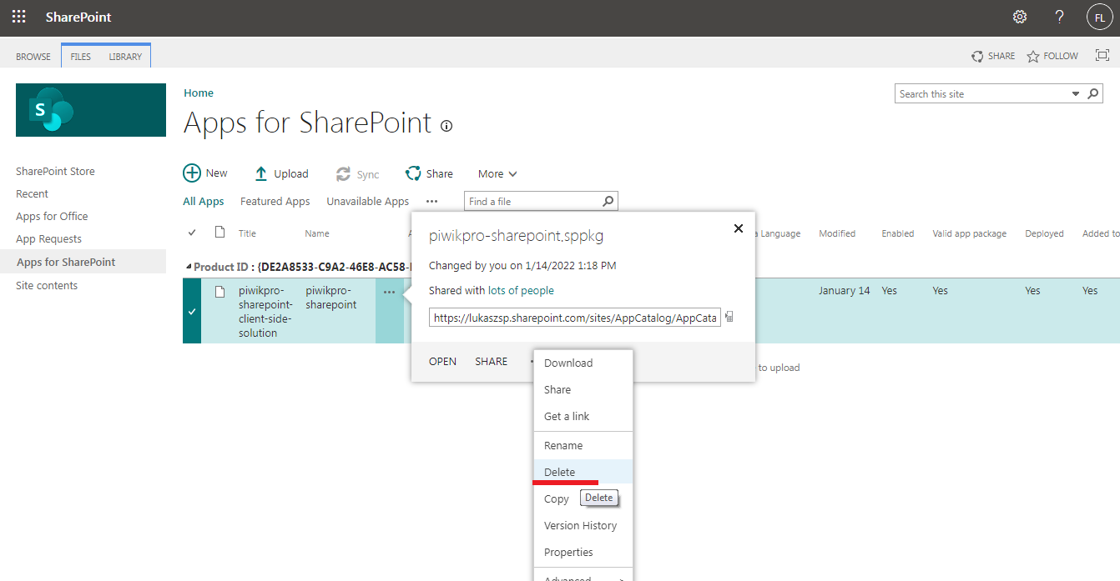

## Removing custom actions by a script

1. Run Windows Powershell as Administrator, navigate to the directory where is a script: PiwikPROTracker_RemoveCustomActionSPOnline.ps1 and run this script by a command:

*.\PiwikPROTracker_RemoveCustomActionSPOnline.ps1 -SharePointUrl* [*https://contoso.sharepoint.com*](https://contoso.sharepoint.com) *-UseWebLogin*

Parameters:

* SharePointUrl (required): URL to your SharePoint tenant
* UseWebLogin – put this switch parameter if you are using Multi Factor authentaction.

*Note: The script could ask you to install PnP Powershell Online which is untrusted repository, please proceed by type A and enter.*

## Removing PiwikAdmin site collection

If the previous step has ended successfully you can optionally remove site collection which name “PiwikAdmin”.

To do it please go to your tenant admin site: {yourtenant}-admin.sharepoint.com, from the left menu open “Active Sites”, find amd select “PiwikAdmin” site collection and click “Remove”.

# Uninstall PiwikPRO components in Azure

## Uninstalling AppService with WebJob

If on your installation was included Azure part then you need to process the following part.

1. Open in the browser portal.azure.com and go to the App Services.
2. Please remove the App Service includes “piwik” in the name.

## Removing App registrations

Optionally you can remove App registration from your Azure Sharepoint tenant.

1. Open in the browser portal.azure.com and go to the App Registrations.
2. Go the one which was created for Piwik and click Delete.